Project Honeypot & Canary Token Monitoring

1. Project Introduction
In this project, I worked on deploying a Cowrie SSH honeypot and creating a Canary Token (Excel-based) to detect and analyse unauthorized access. My objective was to set up deception tools, capture attacker interactions, and validate alerts that could later be used for threat intelligence.
What I learned:
- How honeypots and Canary Tokens are used in deception technology.
- Setting up Cowrie on Kali Linux and running it as a honeypot.
- Creating and testing a Canary Token to generate alerts.
- Collecting and analyzing logs and attacker behavior.

2. Environment & Tools I Used
- Host OS / VM platform: (Kali Linux in VMware / VirtualBox / Cloud – specify exact setup)
- Honeypot: Cowrie (GitHub repo: https://github.com/cowrie/cowrie)
- Canary Tokens: Canarytokens.org (Excel token)
- Utilities & packages: git, python3, virtualenv, pip, netstat, ssh, tail, nano
- Email for Canary Token alerts: (my chosen email address for testing)

3. Steps I Took
- Started a Kali Linux VM.
- Installed the required dependencies and tools.
- Cloned the Cowrie repository.
- Created and activated a Python virtual environment.
- Installed Cowrie dependencies.
- Configured the Cowrie settings file.
- Started Cowrie and checked its status.
- Verified Cowrie was listening on the correct port.
- Simulated an attacker by connecting via SSH.
- Checked the logs to see what activity was recorded.
- Stopped Cowrie after testing.
- Created a Canary Token (Excel) and set the notification email.
- Renamed the Excel file, placed it in a relevant folder, and added fake data.
- Tested the token and received the alert email.

Step 1: Kali Linux Setup and Update
- I installed and started Kali Linux in my virtual environment and updated the system to prepare for the Cowrie honeypot setup.
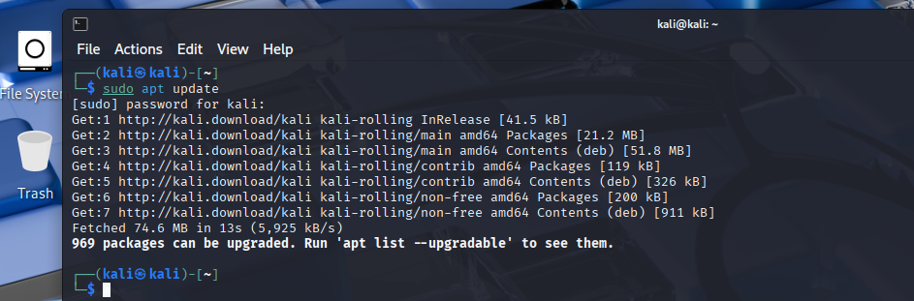

Step 2: Install Cowrie
- I installed the required dependencies (git and python3-virtualenv).
- I created a Python virtual environment for Cowrie to keep its dependencies isolated, ensure stability, improve security, and make it easier to manage.
- Dependency isolation – Cowrie relies on specific Python libraries and versions. A virtual environment keeps these separate from your system’s global Python packages, avoiding conflicts.
- Stability and reproducibility – If you upgrade or change system-wide Python packages, Cowrie might break. The virtual environment ensures Cowrie always runs with the correct versions.
- Security – Since honeypots interact with potentially malicious input, keeping dependencies in an isolated environment reduces the risk of affecting the main system.
- Ease of management – You can activate/deactivate the environment when working with Cowrie, and remove it cleanly if you don’t need it anymore.
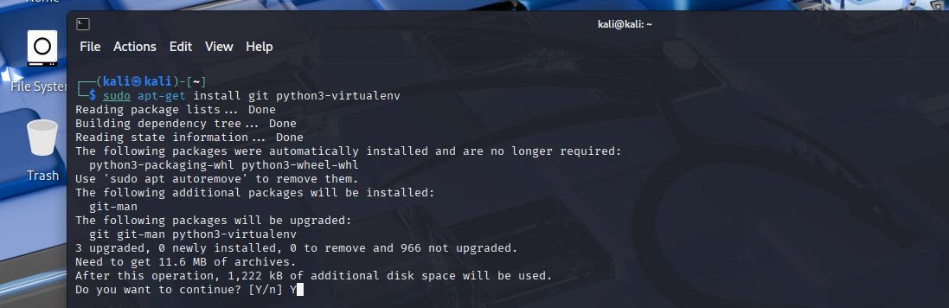

- Then I cloned the official Cowrie repository from GitHub.
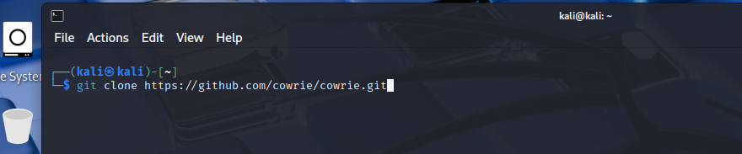

Step 3: Set Up Python Virtual Environment
- I navigated to the Cowrie directory using cd cowrie.
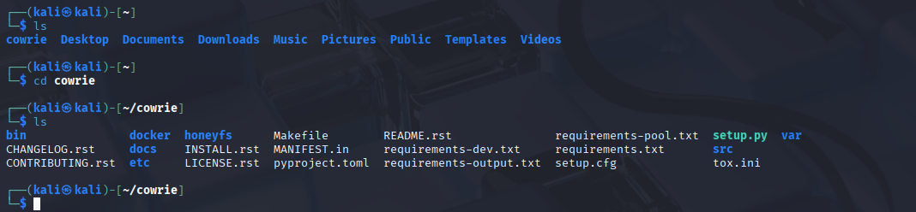
- I created a Python virtual environment for Cowrie with virtualenv -p python3 cowrie-env.
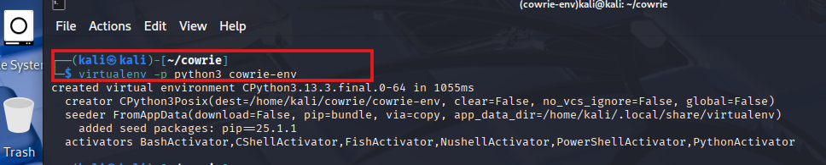
- I activated the virtual environment by running source cowrie-env/bin/activate.
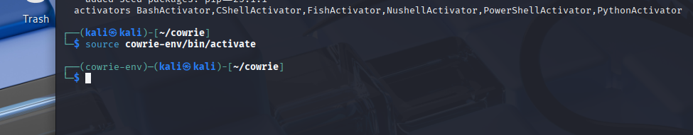

Step 4: Install Required Python Packages
- I installed all the necessary Python dependencies for Cowrie.
- I ran the command pip install -r requirements.txt to complete the installation.
- This ensures Cowrie has all the libraries it needs to run properly and avoid errors.
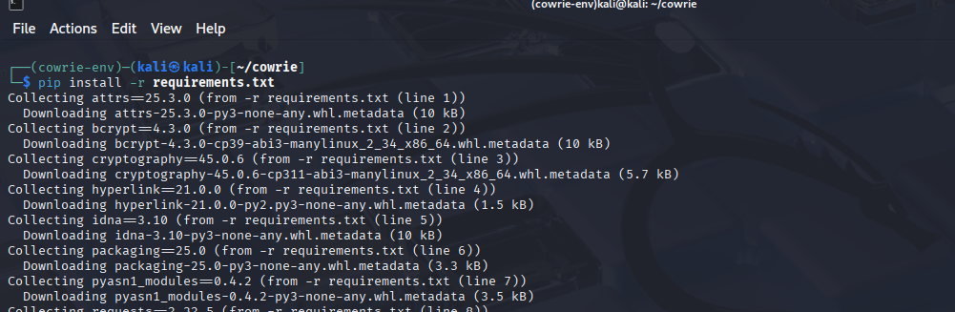

Step 5: Configure Cowrie
- I copied the default configuration file to create my own using cp etc/cowrie.cfg.dist etc/cowrie.cfg.
- This allowed me to customize Cowrie’s settings without altering the original configuration file.
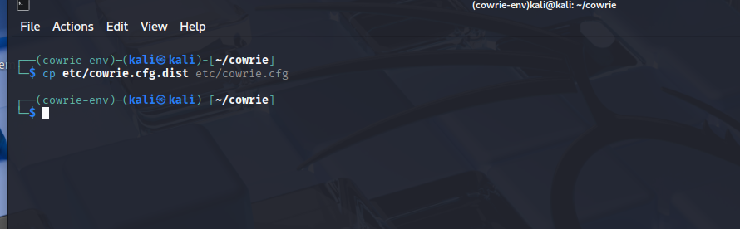
- Although I kept the default port at 2222, I could change the listen_endpoints setting to other ports like 22 for SSH or 80/443 for HTTP if needed.

- Any connection to the chosen port allows me to capture live attacker activity and gather information in real time.
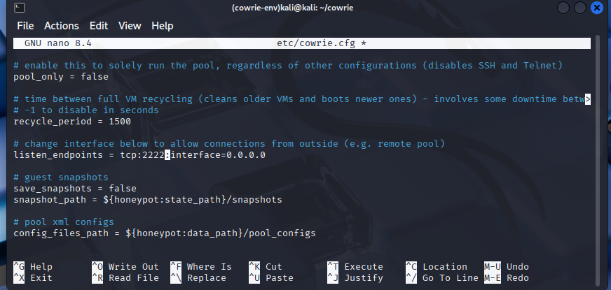

Step 6: Start the Cowrie Honeypot
- I started the Cowrie honeypot by running bin/cowrie start.
- I confirmed it was running and active by checking its status with bin/cowrie status.
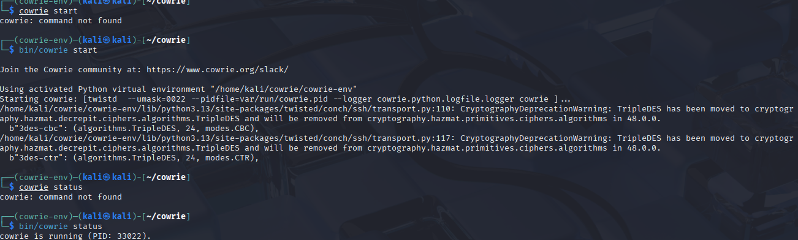

Step 7: Verify Cowrie Listening Port
- I checked if Cowrie was listening on the correct port by running netstat -tuln | grep 2222.
- This confirmed that the honeypot was active and ready to capture any incoming connections.
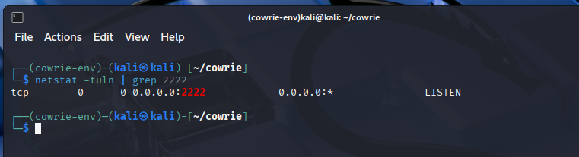

Step 8: Simulate Attacker Connection
- I simulated an attacker by connecting from my Windows host PowerShell to the Kali VM using ssh kali@192.168.1.222 -p 2222.
- This allowed me to see what an attacker would experience when accessing the honeypot.
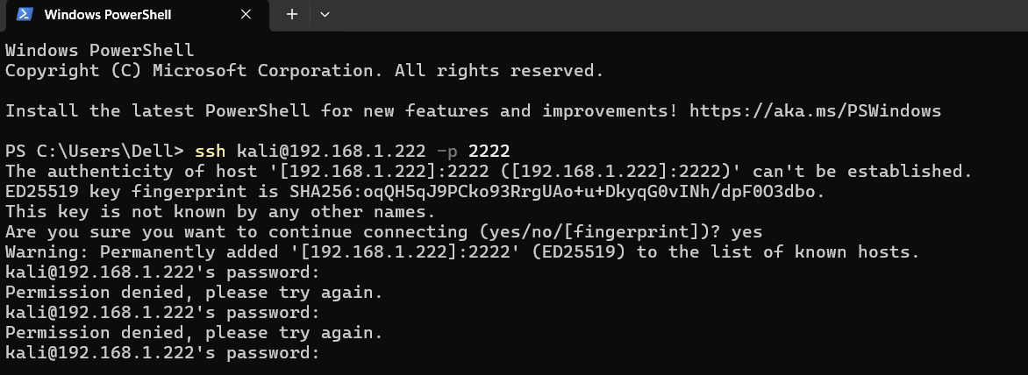

Step 9: View Attack Logs
- I navigated to the Cowrie log directory using cd var/log/cowrie.
- I monitored the log file in real time with tail -f cowrie.log to see all attacker actions and commands as they were recorded.
- While simulating an attacker, I tried connecting with incorrect passwords, and Cowrie recorded each attempt in real time. This allowed me to see how the honeypot captures and logs attacker activity immediately.
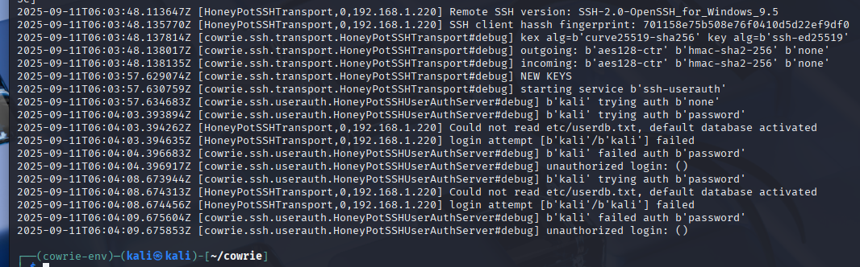
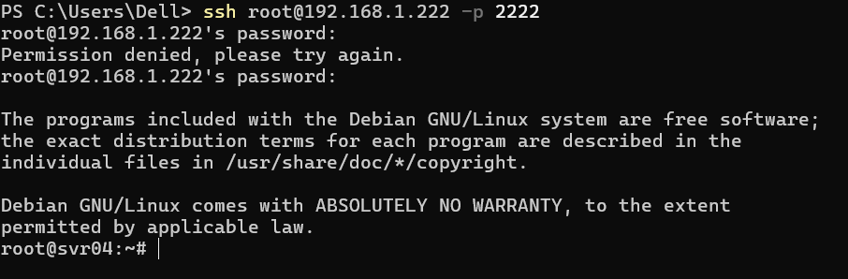
- I observed in the logs that SSH connections to the honeypot were recorded in real time.
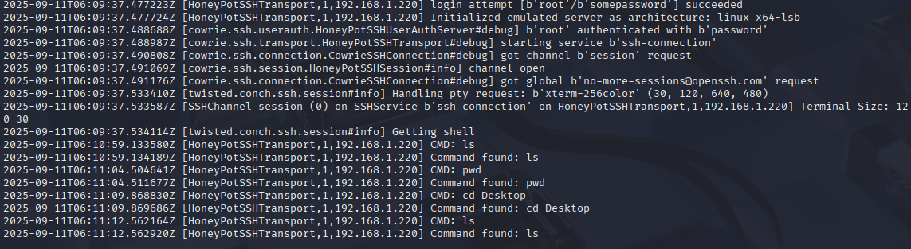

Step 11: Stop the Honeypot
- I stopped the Cowrie honeypot after completing my tests by running cowrie stop.
- This concluded the honeypot session while preserving all logged attacker activity for analysis.

Canary Token Setup

A Canary Token is a small, hidden piece of data or file that I deploy to detect unauthorized access. When it is accessed, it sends me an alert with information about the user or system that triggered it.
- I navigated to the Canary Tokens website at https://canarytokens.org/nest/.
- I selected an Excel file as the token to configure and set up.
- I saw many application options (nests) on the Canary Tokens website.
- I selected the Excel token to create.
- I entered my email address to receive alerts and added a short reminder message.

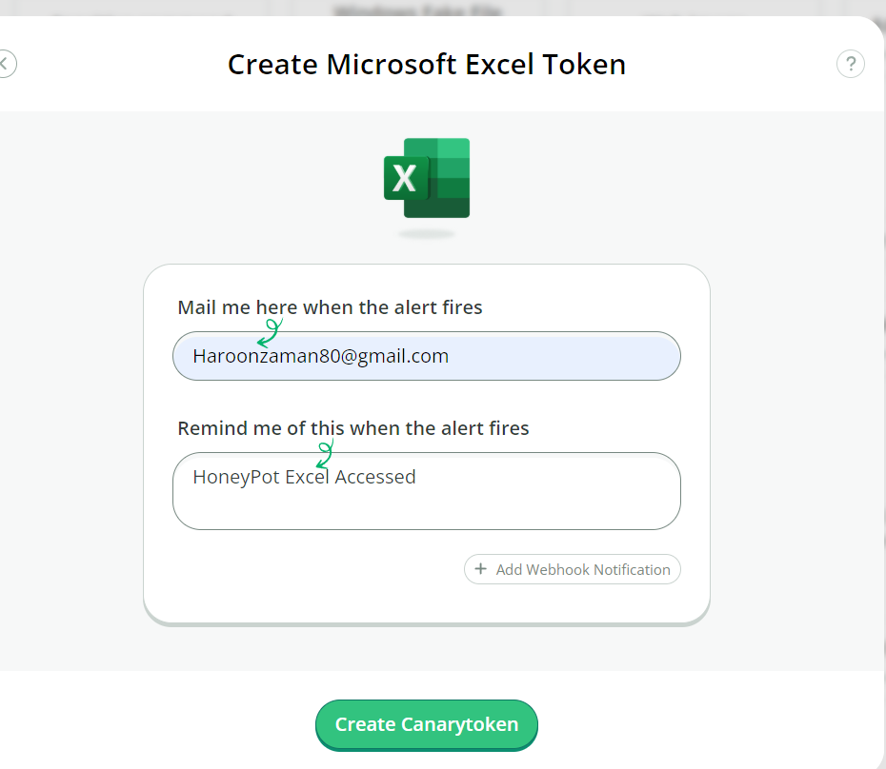
- After clicking “Create Token,” I was taken to the next form where I could download the token file.
- I also noticed a “How to Use This Token” section with instructions on where and how to place the file.
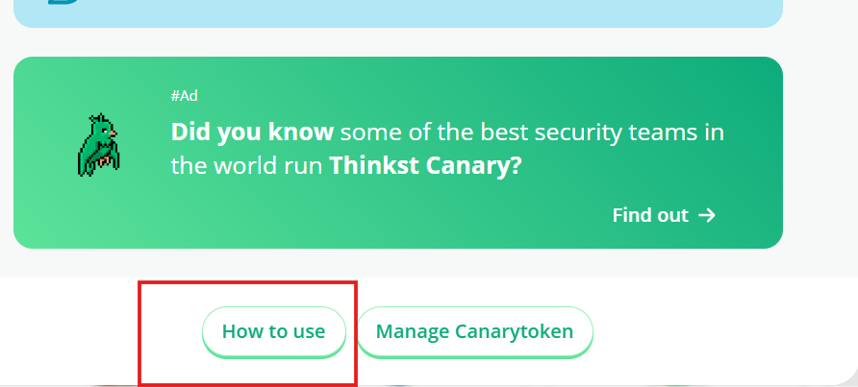
- They provided three different ways to use the token.
- I chose the email method to receive alerts whenever the token was accessed.
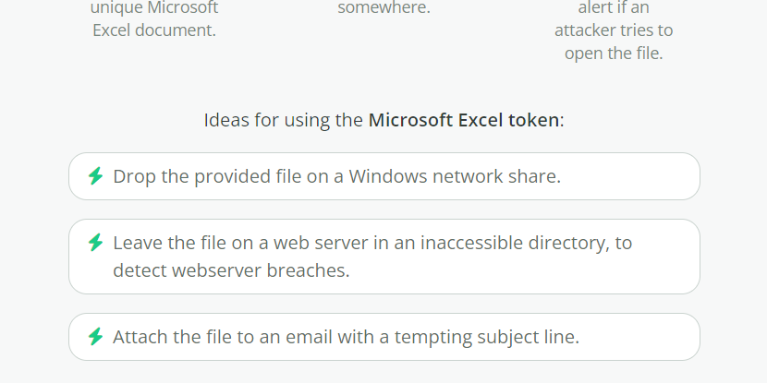
- I clicked back and downloaded the Canary Token file to my system.
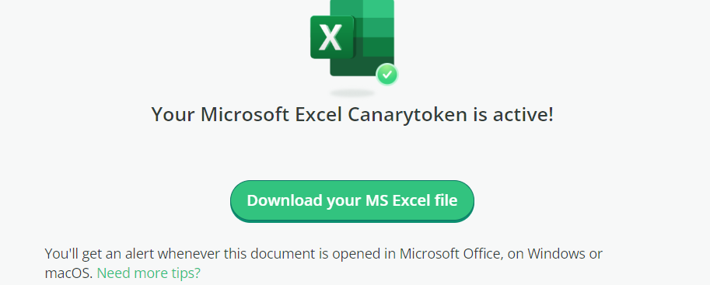
- I renamed the downloaded file to “Accounts” to make it look authentic.
- I added some dummy data to make the file appear convincing.
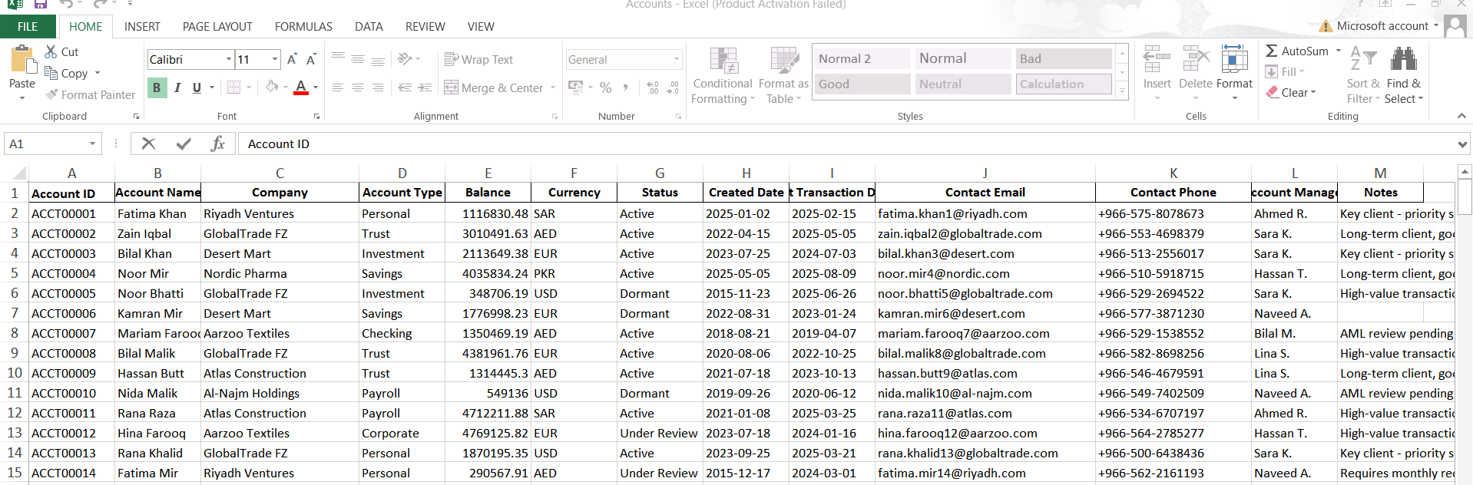
- I started an email from one Gmail account to another to simulate access.
- I did this to test how an attacker might access the file in a real scenario, demonstrating that if the token file were shared or opened by an unauthorized user, I would receive an alert.

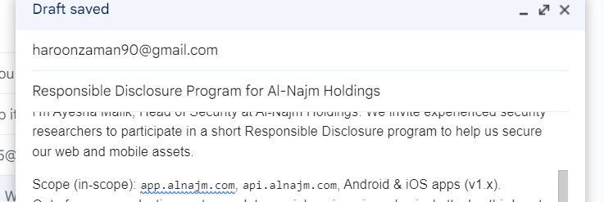

- When the file was downloaded and opened on the other end, simulating an attacker accessing it, I received an alert in the email I had provided when creating the token.
- The email alert included the attacker’s source IP, timestamp, and user agent.
- This information allowed me to track who accessed the token and when.
This showed that the Canary Token successfully detected unauthorized access in real time.
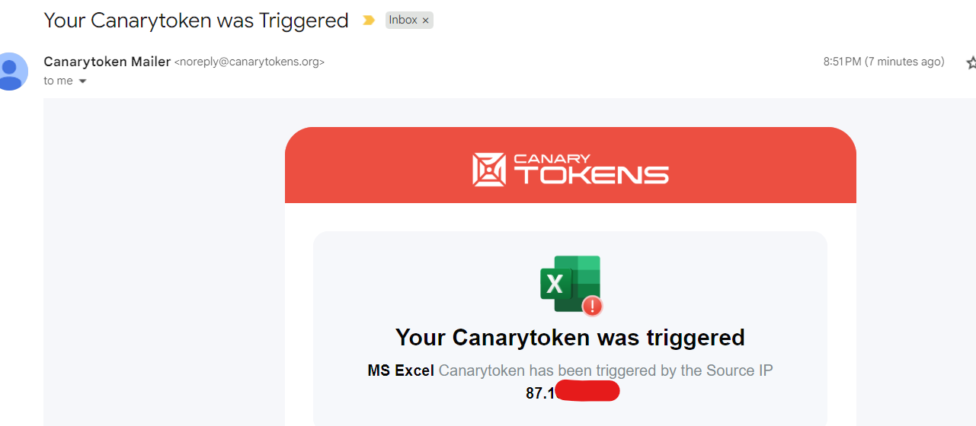

- I scrolled down and clicked the “Alert History” button.
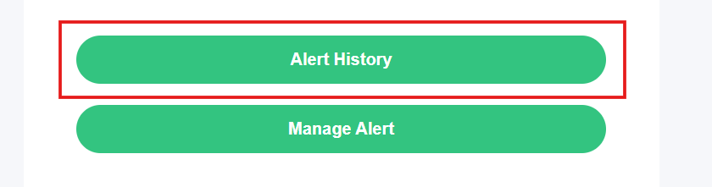

- It redirected me to a page showing the attacker’s source IP, timestamp, user agent, and location on a map.
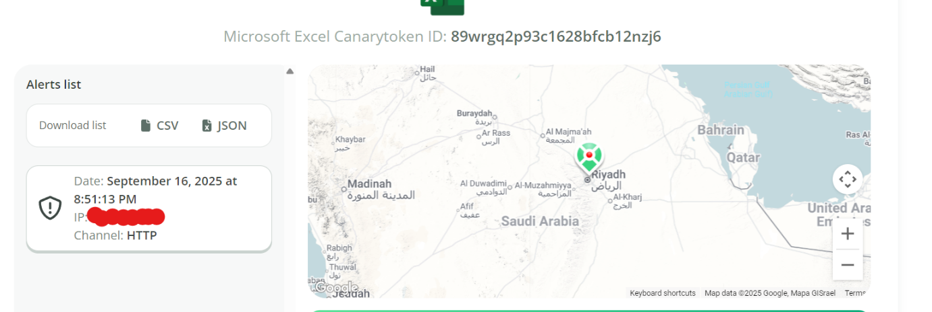
- Back in the email, I clicked “Manage Alert.”
- From there, I could delete the token or redownload it to use it again.
